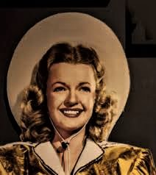

Library Presents Dale Evans - Stories and Songs
Mark your calendars for Saturday, October 2, 2021! Camp Wood Public Library will present a program of stories and songs of the beloved Queen of the West, Dale Evans, featuring talented local entertainers MJ Wofford as the narrator and Toni Hull on the keyboard. The program will be held at the Montell Country Club, which is located on Texas Highway 55 about 35 miles north of Uvalde and 15 miles south of Camp Wood. This event will take place from 2:00 pm until 4:00 pm. Light refreshments will be served. There is no charge for the program, but donations will be gratefully accepted. All proceeds will benefit the Camp Wood Public Library.

