**Camp Wood Public Library Make and Take Crafts**

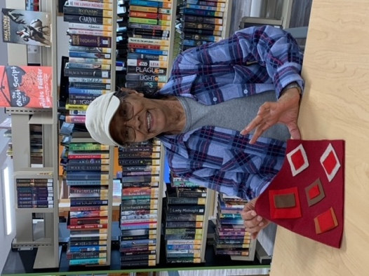 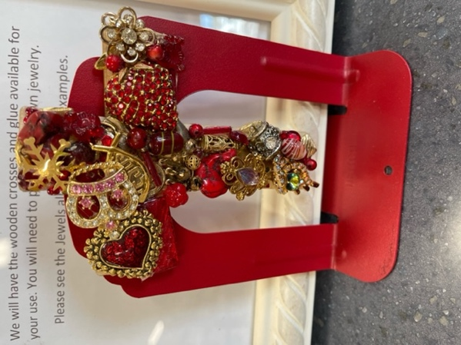 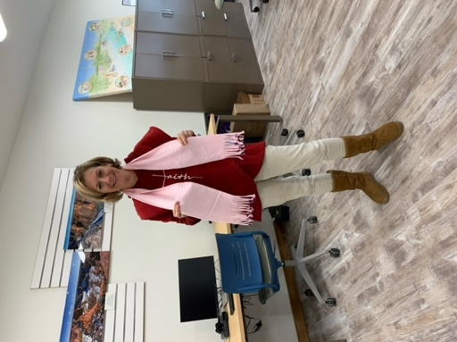 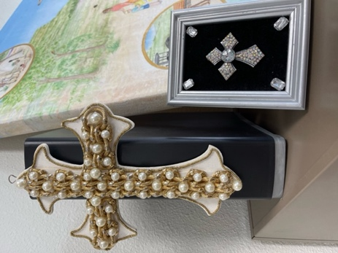

Jewel Crosses

Jewel Crosses

Laura models her scarf.

Marty making a dog pillow!

**Join us the 4th Wednesday of every month from 2 pm to 4 pm for a fun and relaxing time making crafts to take home.**